3GPP TSG RAN WG1 #125 R1-2604029
Dalian, China, May 18th – 22nd, 2026

Agenda item: 10.8.3
Source: CMCC
Title: Discussion on Sensing Waveform
Document for: Discussion and Decision
- Introduction
At RAN1#124bis[1], it was agreed that CP-OFDM will serve as the baseline for 6G ISAC studies. It was further agreed that detailed discussions on evaluation methodologies will be conducted at RAN1#125.
This contribution presents our considerations on potential enhancements to CP-OFDM and the necessity of investigating pulse-based signals. Additionally, we provide analysis on evaluation methodologies and performance metrics for 6G ISAC.
- Discussion on Sensing Waveform
  - Enhancement for CP-OFDM
The CP length determines whether the sensing RS/waveform can meet the coverage requirement. Although bistatic sensing mode exhibits a narrower distance dynamic range (delay spread) relative to the monostatic mode, a 2.344 μs CP at 30 kHz SCS remains insufficient when the target is not located between the Tx/Rx, owing to the blind zones above base stations. As illustrated in the figure below, the delay spread in TRP-UE DL mode lies beyond the CP coverage. Furthermore, under the SMa scenario, the coverage issue becomes more critical.
Figure 1 Coverage issue caused by CP
- Observation 1: CP enhancement is necessary at least for both UMa and SMa scenario.
The cyclic prefix (CP) length limitation can be addressed from the waveform perspective, for example, by introducing new waveforms or an extended CP dedicated to sensing, and can also be resolved using reference signal (RS) design schemes analogous to the RIM RS design. To maintain symbol boundary alignment with communication waveform, addressing this issue via RS design is generally preferred.
Two representative solutions are presented as follows. A frequency-domain comb-2 configuration can achieve an effective CP length exceeding half a symbol, at the cost of energy loss due to the reduced integration interval. Alternatively, a 2OS configuration can achieve an effective CP length exceeding one full symbol, while introducing additional signaling overhead. Both enhancements can be realized purely through RS design and can be readily adopted without modifying the underlying 6G frame structure.
- Comb-2 solution | - 2OS solution
Figure 2 CP enhancement via RS design
- Proposal 1: 6G ISAC shall study CP enhancement, taking the following solution as a starting point:
  - Enhancement by frequency-domain comb
  - Enhancement by concatenation of consecutive symbols
  - Pulse Waveform
Coexistence of all six sensing modes in a serving cell is a typical case for 6G ISAC. To guarantee the sensing performance while maintain an acceptable resource overhead, RS sharing among different Rx devices and among different sensing modes arises as a promising solution. Common design of sensing waveform for all sensing modes is necessary for resource sharing and interference coordination. And if a waveform beyond CP-OFDM is widely applied for TRP-monostatic mode or TRP-bistatic mode, it is important to standardize it for other sensing modes. It indicates that the waveform design should be jointly studied for all sensing modes.
- Observation 2: RS sharing among different Rx devices and among different sensing modes benefits the network resource overhead and the interference coordination.
- Proposal 2: Waveform design for all six sensing modes shall be studied together.
Pulse waveform/signal is widely adopted for NR UAV sensing in our deployment. Owing to isolation constraints between Tx/Rx antennas, transmit power is limited to 35–37 dBm for CP-OFDM waveform, which is insufficient for long-range sensing. By contrast, pulse waveform/signal supports half-duplex operation and low PAPR, allowing transmit power up to 58 dBm and thus achieving significantly better sensing performance.
For 6G sensing, we consider a hybrid OFDM-pulse waveform/signal still necessary for TRP monostatic sensing. Among all use cases, TRP monostatic sensing for UAVs remains the most important scenario identified from a commercial perspective. It can therefore be expected that pulse waveform/signal will very likely occupy certain time, frequency and spatial resources.
- Observation 3: Pulse waveform/signal is necessary for 6G TRP monostatic sensing mode.
Given that pulse waveform/signal for TRP monostatic sensing is highly likely to be employed, standardizing pulse waveform/signal for TRP-involved bistatic modes is necessary to lower network-level sensing overhead. Compared with reusing low-power OFDM signals for bistatic sensing, high-power pulse signals are more reliable and deliver superior performance. For instance, a 35 dBm OFDM symbol (CP excluded) with 33.33 μs duration provides a power level 12 times lower than a 58 dBm LFM pulse with TRP monostatic sensing 2 μs duration.
- Observation 4: Pulse waveform/signal can be reused for bistatic sensing modes to reduce sensing overhead.
In addition, a pulse waveform/signal processed by an OFDM/DFT-s-OFDM demodulator does not suffer from the CP coverage issue. This is due to the large number of zero samples (or low-power samples from echoes outside the region of interest) appended after the echo of interest.
Figure 3 A demonstration of pulse echo received by OFDM/DFT-s-OFDM demodulator
- Observation 5: Pulse waveform/signal does not suffer from the CP coverage issue. And it can be approximately processed by the CP-OFDM demodulator.
Regarding Sub-Urban macro scenario with 30kHz SCS, to achieve an equivalent long CP for 1732m coverage (11.55 μs) via the comb-2 solution, the integration interval is no larger than 24.13 μs. Compared to a 2 μs pulse signal with 58 dBm Tx power, the gap of Rx power between the pulse signal and the OFDM signal is given as:
$$Gap \left(dB\right)=10\log{\frac{{24.13}/2}{10}}-\left(58-52\right)=4.81 dB$$
where a Tx power of 52 dBm is assumed for OFDM waveform. It indicates that, given the same time-domain resource, the performance gap between CP-OFDM and pulse signal decreases immensely when CP enhancement is considered. Reusing TRP-monostatic pulse signal for TRP-UE DL sensing can still provide a relatively good SNR. By adjusting the pulse width, this gap can be further reduced.
- Observation 6: In condition of long-range sensing, the SNR gap between pulse signal and CP-OFDM continue-wave signal is relatively small.
A pulse-like RS generated by carefully designed frequency domain sequence is an alternative solution for implementing CP-OFDM-based pulse signal. Although the Gibbs phenomenon is inevitable due to the frequency domain cutoff, sequence based LFM pulse can still hold a very low PAPR, as shown in Figure 4.
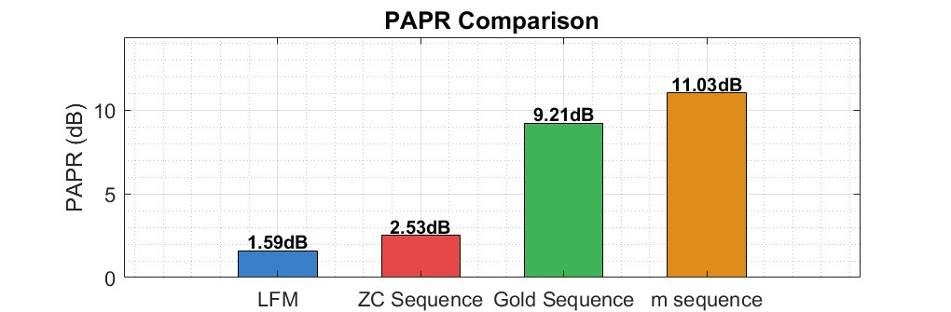
Figure 4 PAPR Comparison
- Observation 7: Pulse waveform/signal provides the best PAPR.
Meanwhile, for long-range sensing, the sidelobe level is of critical importance when accounting for the near-far effect induced by path loss. As illustrated in the following figure, the pulse signal exhibits a much faster sidelobe roll-off, which effectively prevents the masking of weak distant targets.
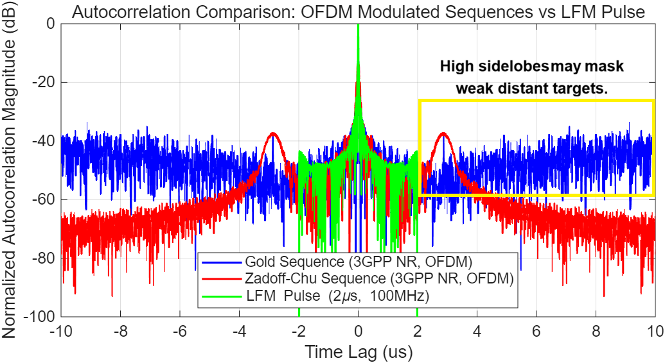
- Observation 8: Pulse waveforms/signal outperform OFDM continuous-wave (CW) waveforms in sidelobe performance, which is particularly beneficial for long-range sensing.
Interference coordination is essential for ISAC when multiple aNBs and UEs are involved. Without prior knowledge of the interfering waveform, victim devices can only treat the received interference as unknown additive noise, which is difficult to suppress. Moreover, it becomes impossible to distinguish between sensing interference and communication interference. Once the interference can be identified as a sensing waveform or reference signal (RS), coordination among TRPs and victim devices can be effectively achieved. Furthermore, through network interaction, the received interference can be repurposed as a sensing RS for either sensing enhancement or communication assistance.
- Observation 9: Standardization of pulse waveform/signal facilitates interference measurement and communication assistance in ISAC systems.
Therefore, we have the following proposal.
- Proposal 3: 6G ISAC shall study and support pulse waveform/signal in all sensing modes for possible RS sharing and reusing. Pulse signal can be supported through at least the following three options:
- Option A: CP-OFDM based new sequence design
- Option B: DFT-s-OFDM
- Option C: New pulse waveform
  - Evaluation of Waveform
- Theoretical Waveform Characteristics Analysis
It is a fundamental analytical approach based on signal processing theory.
- Pros: It can directly evaluate Doppler tolerance, enable straightforward cross-waveform comparison, and derive tight theoretical performance bounds.
- Cons: It cannot reflect realistic end-to-end sensing performance in complex propagation environments and completely ignores interference effects.
- Potential Metrics:
  - Range resolution ($ΔR$): The minimum distance between two co-directional targets that can be distinguished, defined as:
$$ΔR=\frac{c}{2B}$$
where c is the speed of light and B is the signal bandwidth.
  - Ambiguous range ($ΔR_{amb}$): The maximum distance that can be measured without range ambiguity, calculated as:
$$R_{\text{amb}}=\frac{cT_{p}}{2}$$
where $T_{p}$ is the pulse repetition period or the time-domain interval between two sensing symbols.
  - Doppler resolution ($Δv$): The minimum radial velocity difference between two co-located targets that can be resolved, given by:
$$Δv=\frac{λ}{2T_{\text{CPI}}}$$
where $λ$ is the carrier wavelength and $T_{\text{CPI}}$ is the CPI.
  - Ambiguous Doppler (${Dop}_{\text{amb}}$): The maximum radial velocity that can be measured without Doppler ambiguity, determined by the pulse repetition frequency (PRF), given by:
$${Dop}_{\text{amb}}=\frac{1}{T_{\text{CPI}}}$$
Targets with velocities exceeding this value will be folded into the unambiguous velocity interval. This metric is fundamental for designing pulsed radar waveforms for high-speed target detection.
  - Doppler Tolerance: A measure of a waveform's robustness to Doppler frequency shifts. It quantifies the maximum Doppler shift at which the matched filter output SNR loss remains below a predefined threshold (typically 3 dB):
$$\text{Doppler Tolerance}=\max\left\{\left|f_{d}\right| ∣ \frac{{\left|s_{\text{mf}}\left(f_{d}\right)\right|}^{2}}{{\left|s_{\text{mf}}\left(0\right)\right|}^{2}}≥\frac{1}{2}\right\}$$
where $s_{\text{mf}}\left(f_{d}\right)$ is the matched filter output at Doppler shift $f_{d}$.
  - Peak-to-Average Power Ratio (PAPR): The ratio of the maximum instantaneous power of a signal to its average power. High PAPR induces nonlinear distortion in power amplifiers, degrading both communication and sensing performance:
$$\text{PAPR (dB)}=10\log_{10}\left(\frac{{\max_{t}\left|x\left(t\right)\right|}^{2}}{E\left[{\left|x\left(t\right)\right|}^{2}\right]}\right)$$
where $x\left(t\right)$ is the baseband transmitted signal.
  - Peak-to-Sidelobe Ratio (PSLR): The ratio of the main lobe amplitude to the largest sidelobe amplitude in the ambiguity function or matched filter output:
$$\text{PSLR (dB)}=20\log_{10}\left(\frac{\text{Main lobe peak amplitude}}{\text{Maximum sidelobe amplitude}}\right)$$
A high PSLR prevents strong nearby targets from masking weak distant targets.
Note that all the metrics above can be evaluated by the ambiguous function (AF).
- Link-Level Simulation (LLS)
LLS simulates physical layer transmission between a single (pair of) BS(s) and target(s) under controlled channel conditions.
- Pros: It retains the ability to evaluate Doppler tolerance and has low implementation complexity.
- Cons: It strictly depends on predefined LLS channel models (which is yet to be discussed), cannot evaluate inter-cell/intra-cell interference, and fails to assess multi-target detection performance if the channel model does not support multiple scatterers.
- Potential Metrics:
  - Miss detection probability
  - False alarm probability
  - Localization accuracy
  - Velocity accuracy
- System-Level Simulation (SLS)
SLS models the entire cellular network with multiple BSs, targets, and interference sources.
- Pros: It can evaluate network-level performance (e.g., inter-cell interference) in multi-BS deployments, leverages the standardized 3GPP TR 38.901 channel model, and inherently supports multi-target detection evaluation.
- Cons: It requires full implementation of the new waveform, demands consensus on evaluation assumptions, and has inherent limitations in accurately evaluating Doppler tolerance (due to the simulation overhead).
- Potential Metrics:
  - Miss detection probability
  - False alarm probability
  - Localization accuracy
  - Velocity accuracy
The advantages, limitations, and potential quantitative metrics are summarized in Table 1.
Table 2 Comparison of Theoretical waveform characteristics analysis, LLS and SLS
 | Theoretical waveform characteristics analysis | LLS | SLS
Pros. | - Can evaluate the Doppler tolerance  - Easy for evaluation and comparison  - Can provide theoretical performance | - Can evaluate the Doppler tolerance  - Easy for implementation | - Can evaluate network performance (e.g. interference) if multiple BS are dropped  - Existed channel model in TR38.901  - Can evaluate performance of multi- targets detection
Cons. | - Cannot reflect the final sensing performance  - Cannot evaluate interference | - Requires LLS channel model  - Cannot evaluate interference  - Cannot evaluate performance of multi-targets detection, if the LLS channel model does not support multiple targets | - Requires implementation of new waveform  - Requires consensus on evaluation assumptions  - Hard to evaluate the Doppler tolerance
Metrics | - Range resolution  - Ambiguous range  - Doppler resolution  - Ambiguous Doppler  - Doppler tolerance  - PAPR  - PSLR | - Miss detection probability  - False alarm probability  - Localization accuracy  - Velocity accuracy | - Miss detection probability  - False alarm probability  - Localization accuracy  - Velocity accuracy
- Observation 10: Theoretical analysis is optimal for initial waveform design and screening, LLS are optimal for physical layer performance validation, and SLS are optimal for end-to-end network-level sensing performance verification.
- Proposal 4: Theoretical waveform characteristics analysis is adopted as the starting point of waveform study of 6G ISAC. LLS can be further implemented if a LLS channel model is agreed.

Conclusions
Our observations and proposals are as follows:
- Observation 1: CP enhancement is necessary at least for both UMa and SMa scenario.
- Observation 2: RS sharing among different Rx devices and among different sensing modes benefits the network resource overhead and the interference coordination.
- Observation 3: Pulse waveform/signal is necessary for 6G TRP monostatic sensing mode.
- Observation 4: Pulse waveform/signal can be reused for bistatic sensing modes to reduce sensing overhead.
- Observation 5: Pulse waveform/signal does not suffer from the CP coverage issue. And it can be approximately processed by the CP-OFDM demodulator.
- Observation 6: In condition of long-range sensing, the SNR gap between pulse signal and CP-OFDM continue-wave signal is relatively small.
- Observation 7: Pulse waveform/signal provides the best PAPR.
- Observation 8: Pulse waveforms/signal outperform OFDM continuous-wave (CW) waveforms in sidelobe performance, which is particularly beneficial for long-range sensing.
- Observation 9: Standardization of pulse waveform/signal facilitates interference measurement and communication assistance in ISAC systems.
- Observation 10: Theoretical analysis is optimal for initial waveform design and screening, LLS are optimal for physical layer performance validation, and SLS are optimal for end-to-end network-level sensing performance verification.
- Proposal 1: 6G ISAC shall study CP enhancement, taking the following solution as a starting point:
  - Enhancement by frequency-domain comb
  - Enhancement by concatenation of consecutive symbols
- Proposal 2: Waveform design for all six sensing modes shall be studied together.
- Proposal 3: 6G ISAC shall study and support pulse waveform/signal in all sensing modes for possible RS sharing and reusing. Pulse signal support can be supported through at least the following three options:
  - Option A: CP-OFDM based new sequence design
  - Option B: DFT-s-OFDM
  - Option C: New pulse waveform
- Proposal 4: Theoretical waveform characteristics analysis is adopted as the starting point of waveform study of 6G ISAC. LLS can be further implemented if a LLS channel model is agreed.

References
- 3 GPP R1-2603284, " Session Notes of AI 10.8 (ISAC)", April, 2026.

